Below are links to posters which may be beneficial posted on noticeboards in your community centre. Users of community centres encompass all ages and signposting information below can help your community become informed, empowering them to make positive decisions on their health through access to up-to-date-accurate information. Given the time of year it is also important to be aware and know where to access advice and support regarding your physical and mental health and wellbeing.
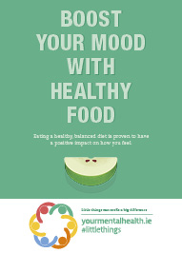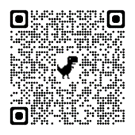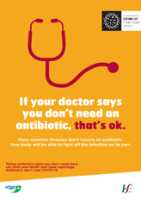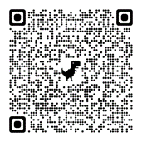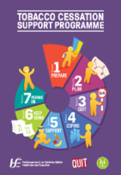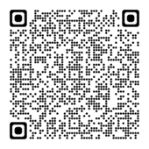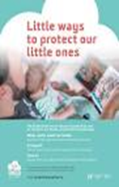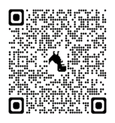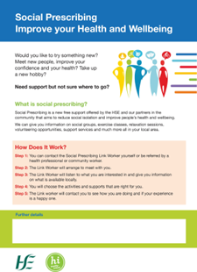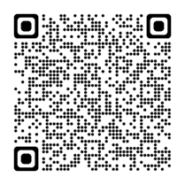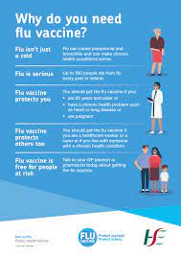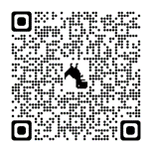
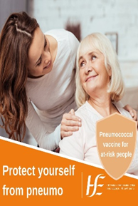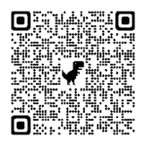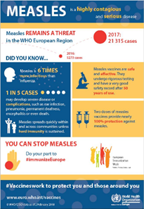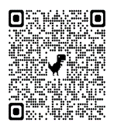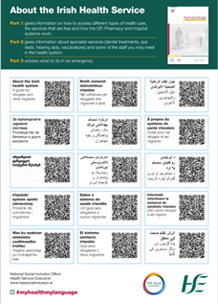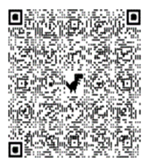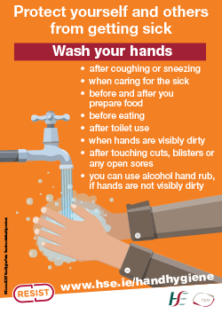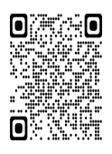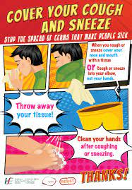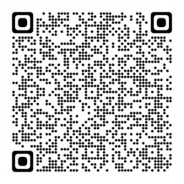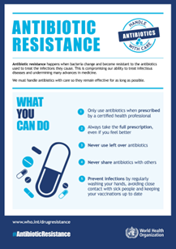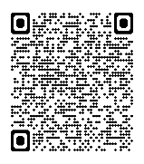

Some leaflets referenced above and other information can be found translated into different languages at websites below:
https://www.hse.ie/eng/about/who/primarycare/socialinclusion/about-social-inclusion/translation-hub/multilingual-resources-and-translated-material/
https://www.hse.ie/eng/health/immunisation/pubinfo/vaccinesireland/
Further advice and information can be found at:
https://www.hse.ie/eng/health/immunisation/pubinfo/adult/pneumo/ppveng.pdf
https://www.hse.ie/eng/health/immunisation/pubinfo/
https://www2.hse.ie/living-well/winter/how-to-stay-well-in-winter/
https://www.hse.ie/eng/about/who/healthwellbeing/our-priority-programmes/mental-health-and-wellbeing/
https://www2.hse.ie/conditions/antibiotics/
Useful factsheets can be printed and made available in an accessible area in the centre if wished:
https://www2.hse.ie/conditions/diarrhoea-vomiting/ https://www2.hse.ie/conditions/high-temperature/
https://www2.hse.ie/conditions/earache/ https://www2.hse.ie/conditions/fever-adults/
https://www2.hse.ie/conditions/sore-throat/ https://www2.hse.ie/conditions/fever-adults/
https://www2.hse.ie/conditions/common-cold/ https://www2.hse.ie/conditions/dehydration/
https://www2.hse.ie/conditions/flu/ https://www2.hse.ie/conditions/sinusitis/
https://www2.hse.ie/conditions/rash/

